Data Analysis - Trends of Sports Market in Istanbul and Predicting the Next Trend

Date: 31.07.2020

Prepared by: Resat Caner Bas

Table of Contents

2 Introduction 2

2.1 The Problem 2

2.2 The Interest 2

2.3 Data Collection 2

2.3.1 Database Details 4

3 Exploring the Data 5

3.1 The Distribution Graphic of Venues over Time 6

3.2 Distribution Graphics of each Venue Type over Time 9

3.3 Venue Rating Distribution Graphics 10

3.4 Half Time Information 11

4 Conclusion 12

4.1 Clustering 12

4.2 Decision Tree 13

# Introduction

Individual sports become more and more popular all over the globe due to raise of the self-awareness and well-being philosophy is spreading among people.

## The Problem

As a result, many disciplines of sports become more and more popular. However, not all of them become more popular and almost none of them can keep itself as the most preferred one.

In this report, you will find an analysis of sports market in Istanbul, more specifically, Kadikoy and Besiktas Towns and an prediction for an upcoming trend if possible.

## The Interest

The results of this report may give a deeper insight to the investors planning to find a business targeting the sports market around the Istanbul and in other regions.

## Data Collection

The Data is collected in the data gathering notebook.

Kadikoy and Besiktas are one of the towns in Istanbul and Turkey that is one of the highest cultural and financial levels in Turkey. This makes them a great candidate to inspect the trends as these regions are generally flag carriers for such trends.

* The neighborhoods of these towns are used. The data of this collected from Turkish Postal Office Database

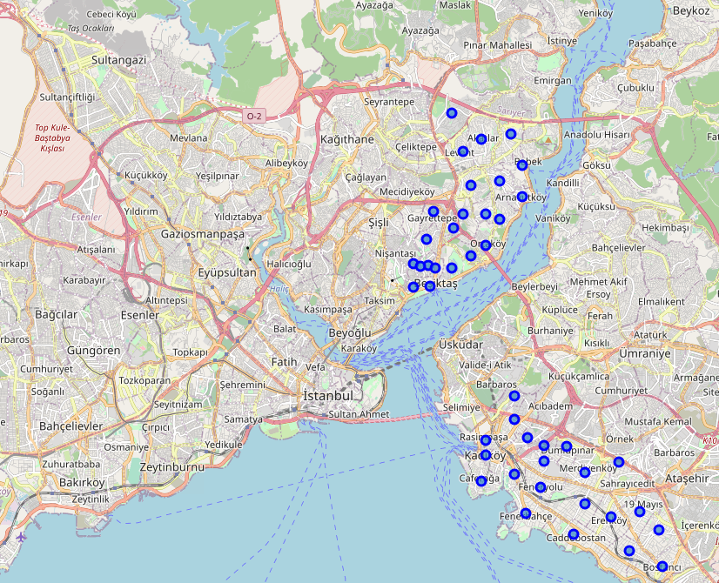

Figure 1-Neighborhood Centers

* Longitude and Latitude data related to the neighborhoods are collected via Google Geocoding API.
* Venue details are collected via **Foursquare Places API**
* Venue details are broken into two databases of Kadikoy neighborhoods and Besiktas Neighborhoods and saved as **kadikoy_venues.csv** and **besiktas_venues.csv**

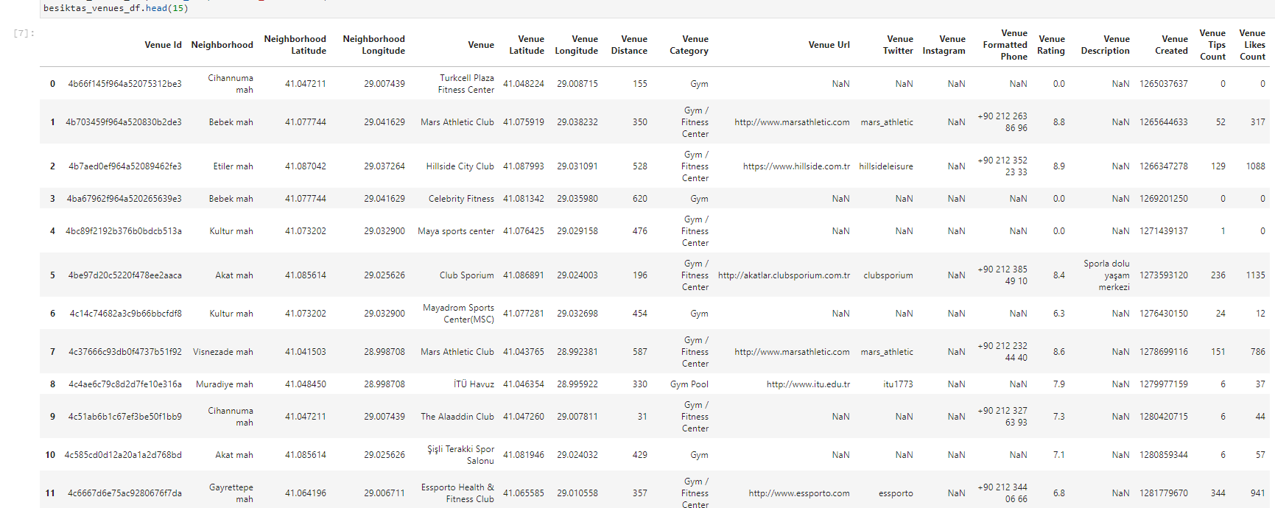

Figure 2- Head of besiktas_venues.csv

### Database Details

|  |  |
| --- | --- |
| **Column Name** | **Column Detail** |
| **Venue Id** | ID of venue on Foursquare |
| **Neighborhood** | Name of the neighborhood |
| **Neighborhood Latitude** | Latitude of the neighborhood |
| **Neighborhood Longitude** | Longitude of the neighborhood |
| **Venue** | Name of the venue |
| **Venue Latitude** | Latitude of the venue |
| **Venue Longitude** | Latitude of the venue |
| **Venue Distance** | The distance in between the venue and the neighborhood center |
| **Venue Category** | The category of the venue on Foursquare |
| **Venue Url** | The url of the venue homepage on Foursquare |
| **Venue Twitter** | The recorded twitter account of the venue on Foursquare |
| **Venue Instagram** | The recorded instagram account of the venue on Foursquare |
| **Venue Formatted Phone** | The recorded phone number of the venue on Foursquare |
| **Venue Rating** | The rating of the venue on Foursquare |
| **Venue Description** | The description of the venue on Foursquare |
| **Venue Created** | Venue creation date on Foursquare in Epoch |
| **Venue Tips Count** | The number of tips of the venue on Foursquare |
| **Venue Likes Count** | The number of likes of the venue on Foursquare |

# Exploring the Data

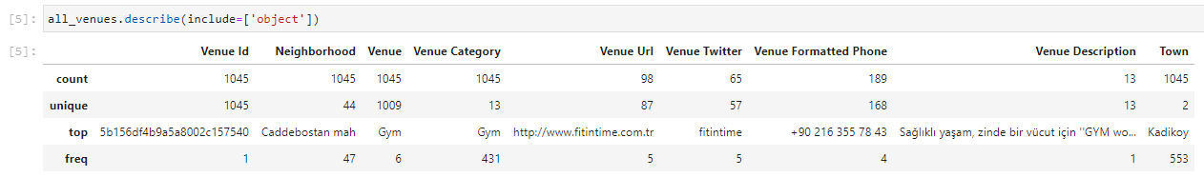

Figure 3- Description of Dataframe

According to the description

1. Kadikoy is the town with most venues
2. Caddebostan is the neighborhood with most venues
3. Gym is the most dominant category (41%)

Here is the distribution of categories:

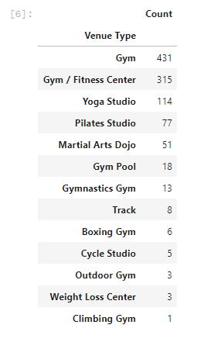

Figure 4- The Distribution of Venue Categories

## The Distribution Graphic of Venues over Time

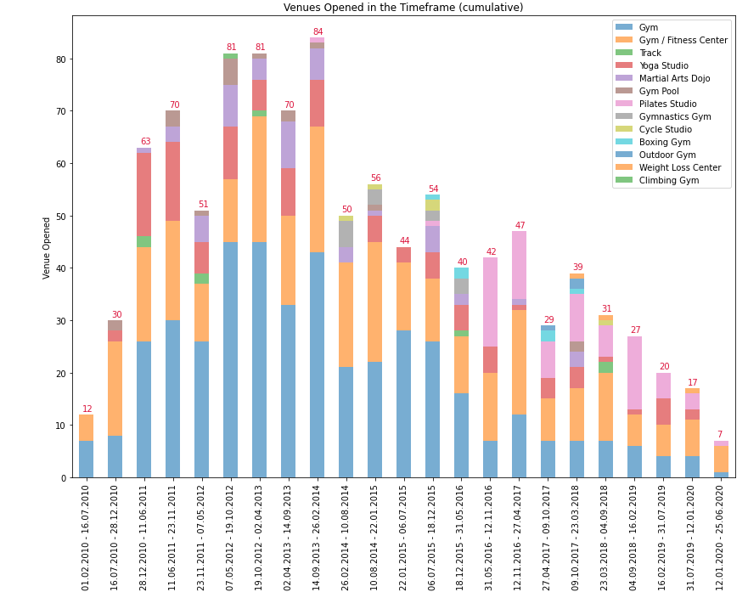

Figure 5- Distribution of Venues over Time in all Neighborhoods

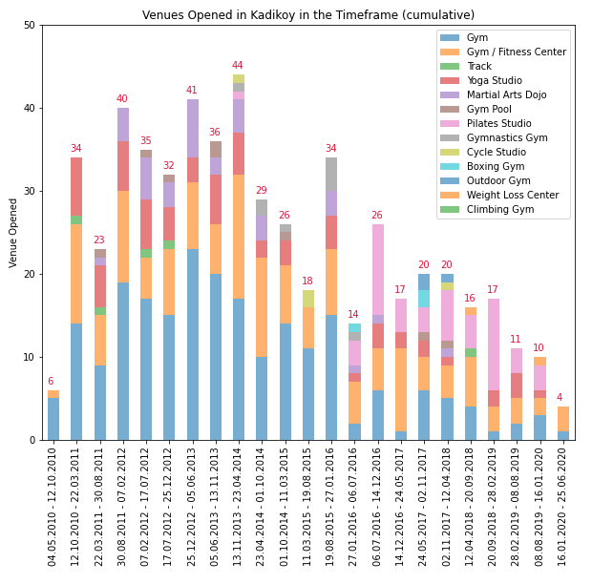

Figure 6- Distribution of Venues over Time in Kadikoy Neighborhoods

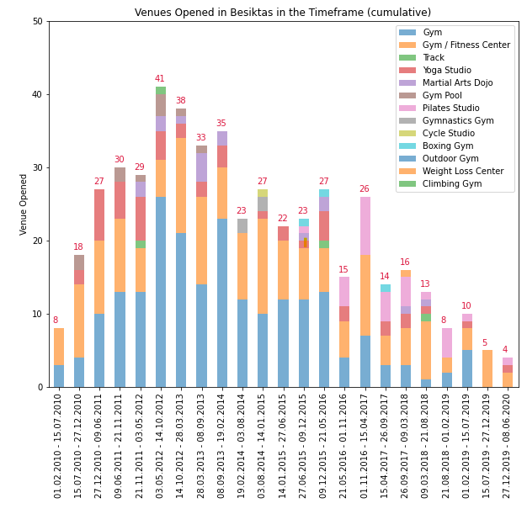

Figure 7- Distribution of Venues over Time in Besiktas Neighborhoods

## Distribution Graphics of each Venue Type over Time



Figure 8- Distribution Graphics of each Venue Type over Time

## Venue Rating Distribution Graphics



Figure 9- Venue Rating Distribution Graphics

## Half Time Information

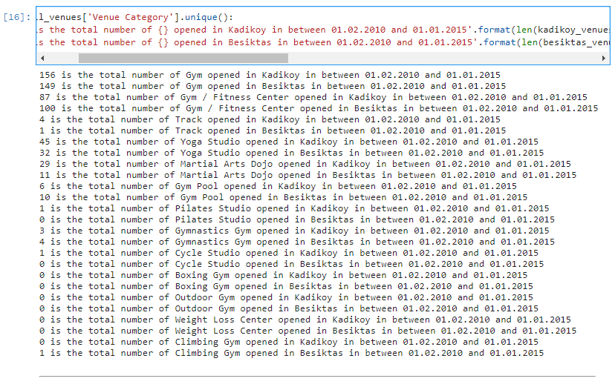

Figure 10- Half Time Cumulative Venue Distribution

On the halfway, the numbers look identical, however Kadikoy is leading for **Gym, Track, Track Yoga Studio, Martial Arts Dojo and Pilates Studio** categories whereas Besiktas is leading **the Gym / Fitness Center, Gymnastic Gym and Gym Pool** categories.

# Conclusion

At first glance, Gyms and Gym fitness center seems to dominate all the regions, however it can’t be neglected the Yoga Studio, Pilates Studio and Martial Art Dojo venues have strong trends. According to the trends, Kadıköy seems one step ahead for those popular categories. It could be a good advice to follow trends in Kadıköy and apply them in other regions to catch the trend. 2 different ML methods are applied to reach the best results to predict the most profitable investment out of the dataset.

## Clustering

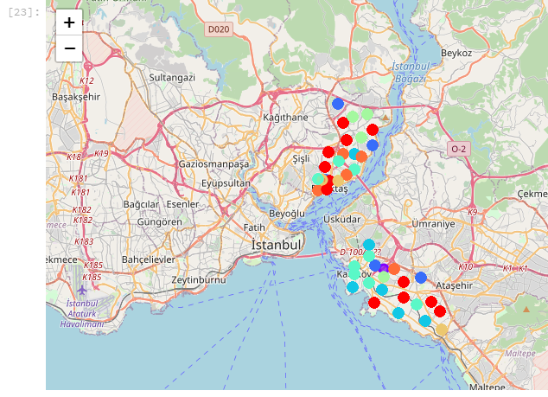

Figure 11- Cluster Map

Clustering gives a great overview to see where the deviations for categories are. For example, in cluster 6, Yoga Studio is the 2nd most common venue, and it might be good to consider an investment on Turkali Mah. neighborhood. The *frequency* of the *Venue Category* is the base of the model.



Figure 12 - Cluster 6 of Neighborhoods

Similar deductions can be made depending on the clustering.

## Decision Tree

Decision Tree is created based on following features:

Venue Created : Date  
Neighborhood : Location

Due to the domination of ***Gym*** and ***Gym Fitness Center*** categories, the accuracy of the Decision Tree is affected. It tends to locate the result in between those two categories.

However, it is acceptable with the dataset except those categories. According to the result of the tree, it could be the best to invest on a **Pilates Studio in Kadikoy-Caddebostan, in September**. Similar predictions can be made using the model.

Figure 13 - Decision Tree

